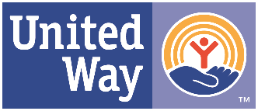
Gifting Stocks, Bonds, and Mutual Funds to the United Way of Lee County

-Bypass capital gains taxes.
-Give a large gift with less cost to you!

Call us for additional assistance.

1. If share are held at your brokerage firm, trust department of financial
institution:

A. Call the United Way of Lee County at 239-433-7201 to pledge.

B. Notify your financial institution of the description and quantity of the transfer to United Way.

C. Securities should be transferred to " United Way of Lee County account #81472146, DTC 0725 (Raymond James & Assoc., Inc.)
The contact is Becky Pardue 239-936-6300

D. Please ask the financial institution to notify United Way of the expected gift as funds are transferred to our broker with no donor name listed.

E. The United Way will provide you with the documentation of your gift.

United Way of Lee County
7273 Concourse Drive
Fort Myers, FL 33908
Phone 239-433-7201
Darren@UnitedWayLee.org
Fax 239-433-5692
Web Address www.UnitedWayLee.org
Federal Tax ID # 59-1005169

