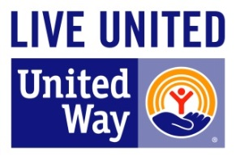

Letter to be furnished by Donor to their IRA administrator/broker/mutual fund

December _____, 20__

IRA Administrator/Broker/Mutual Fund Group/Custody Agent
Name
Address

RE: IRA Charitable Rollover for the Tax Year 20__

Dear Sir/Madam,

I wish to make a charitable distribution directly from my Individual Retirement Account (#________________) to United Way of Lee County, Federal Tax ID # 59-1005169.

Please transfer $ _____________________ to United Way in full or partial satisfaction of my minimum required distribution for year 20__, and complete this transfer before December 31.

The qualified charitable distribution should be made directly to United Way at:
Bank Name __Bank of America, N.A.____________________________
Bank Address _13099 S. Cleveland Ave, 4th Floor, Fort Myers, FL 33907
Bank account # __8980 5244 7962
ABA routing # ___063100277___________________________________

United Way is a qualified organization to receive this IRA charitable rollover gift, and is neither a donor advised fund nor a supporting organization. No goods or services will be provided in exchange for this contribution.

In your transmittal to United Way, please reference my name and address as the donor of record in connection with this transfer, and copy me on your transmittal.

If you have any questions, please call me at (___) _____ or Darren Phillips at United Way at
(239) 433-7201.

Thank you.

Sincerely,

Donor Name

CC: Jeannine Joy at United Way of Lee County, 7273 Concourse Drive, Fort Myers, FL 33908
For donor: Please retain this letter with your important tax documents.

